What Is a Chatbot?
A chatbot is defined as a conversational application that aids in customer service, engagement, and support by replacing or augmenting human support agents with artificial intelligence (AI) and other automation technologies that can communicate with end-users via chat.

Types of Chatbots

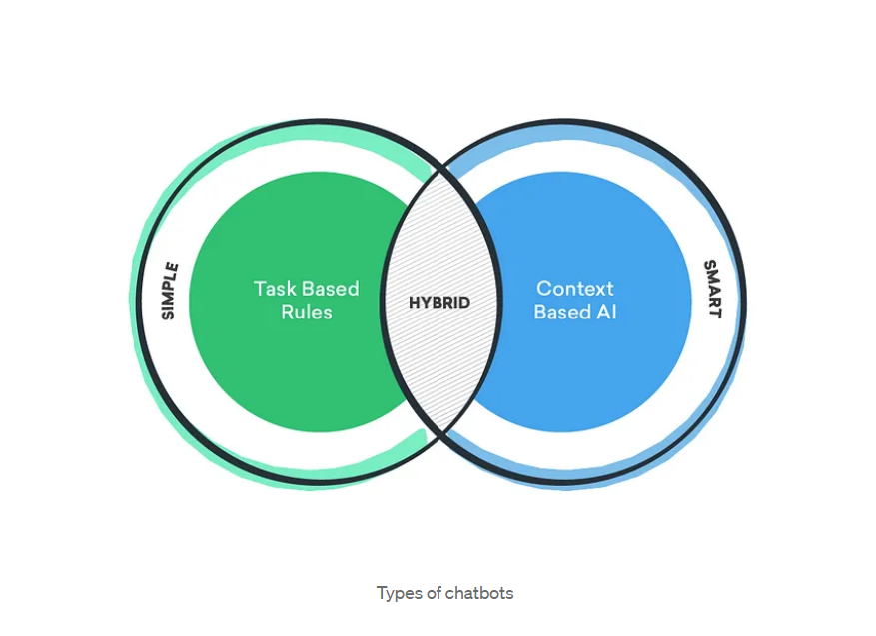

Kinds of Chatbots
Voice Bots, Hybrid Chatbots, Social Messaging Chatbots, Menu-based Chatbots, Skills Chatbots & Keyword-based Chatbots, Rule-based Chatbots, AI-powered contextual chatbots, Support Chatbots, Transactional Chatbots, No-code / low-code chatbots.

Major Applications of Chatbots
Customer service, E-commerce and sales, Booking and reservation requests, Informational and educational content, Entertainment.
Chatbot idea

When user will be given options to choose, disable text.
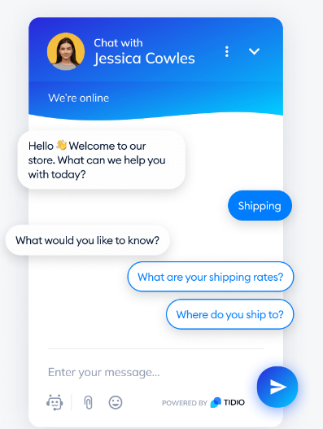
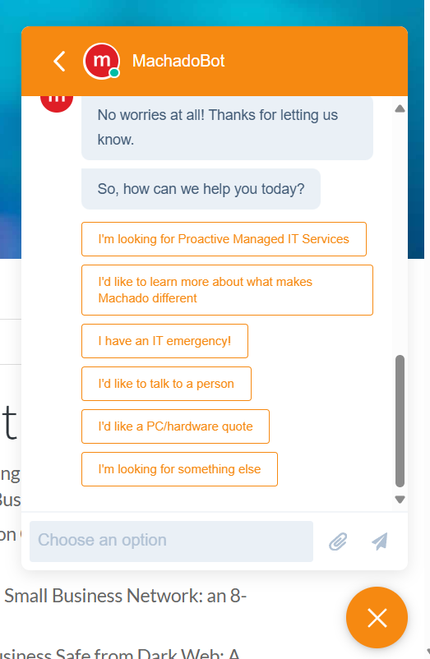
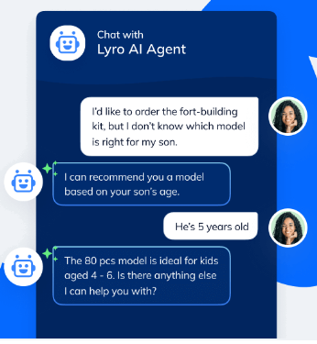

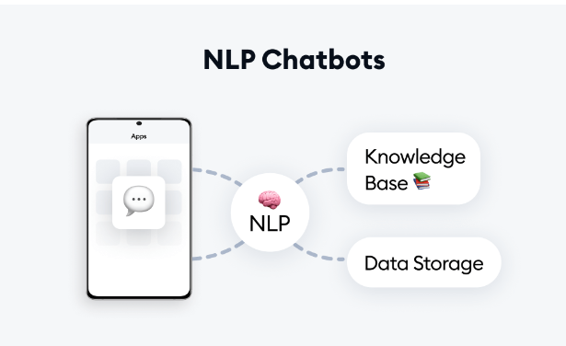

*****There’s a built-in python file at: C:\Users\Vijay\AppData\Local\Programs\Python\Python312\Lib\site-packages\nltk\chat\util.py
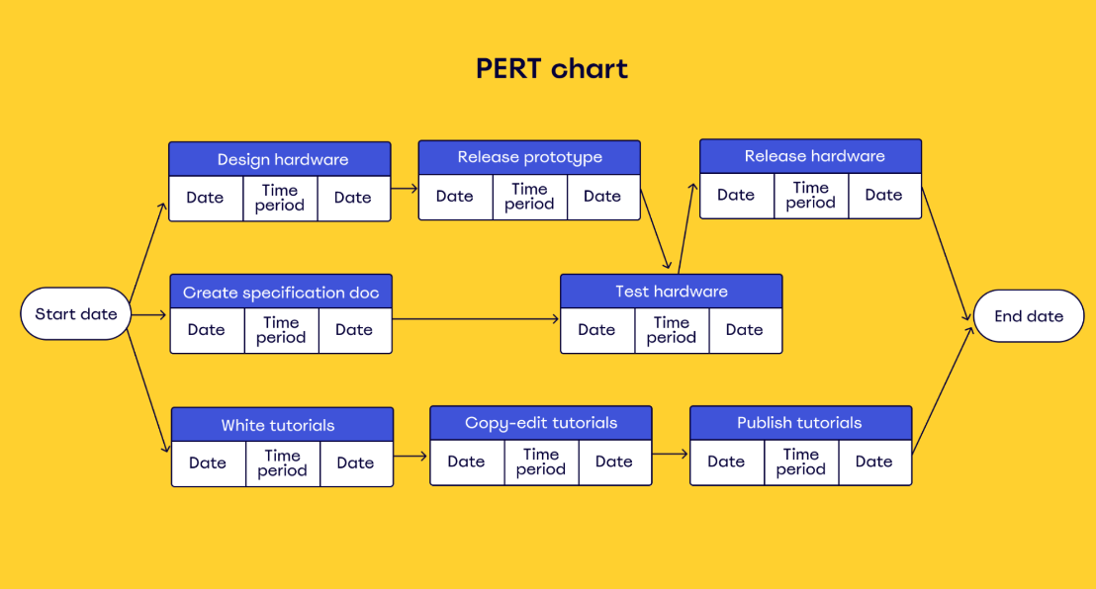
This file contains all responses like what to say when users say I, You, etc.

